Exercise 2: E-commerce Platform Search Function – Analysis

Implementation:
Main.java:
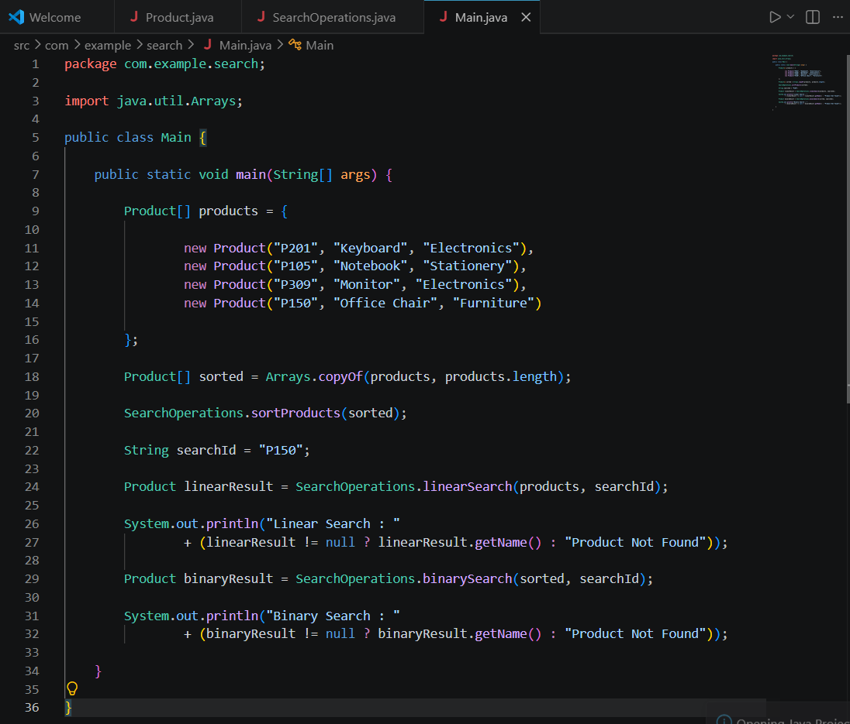

Product.java:
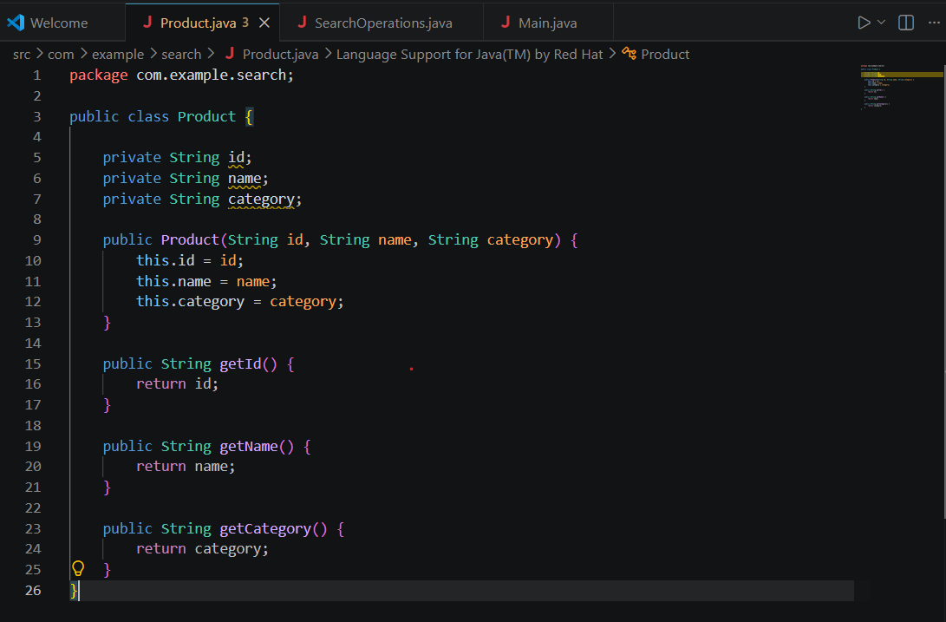

SearchOperations.java:
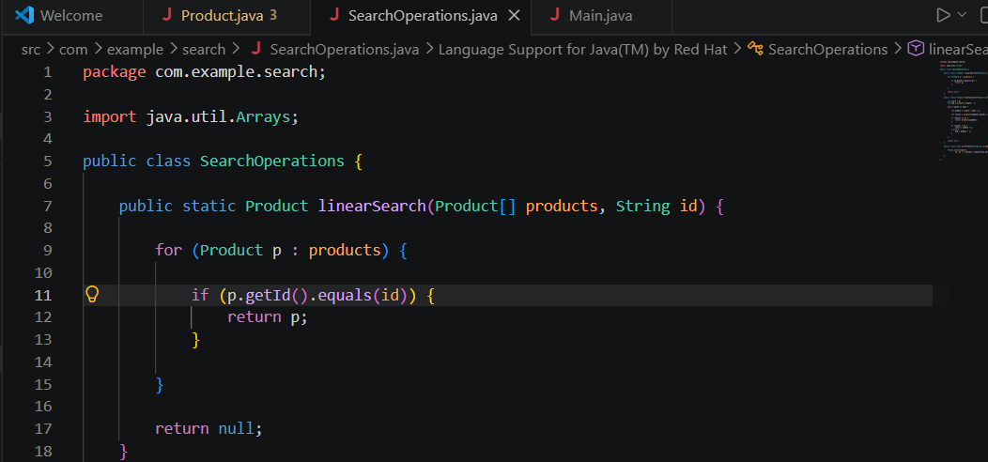

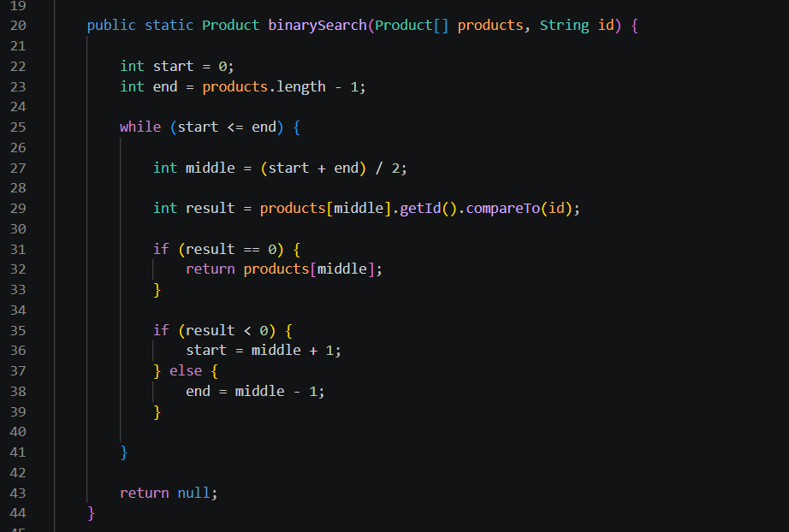

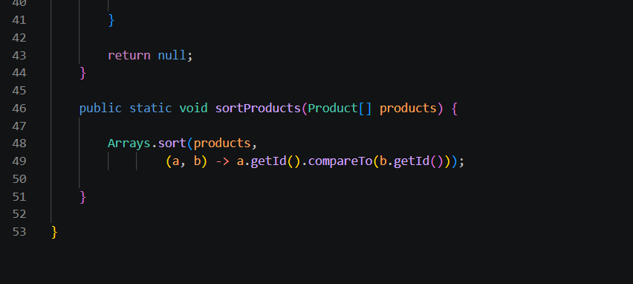

1. Big O Notation:
Big O notation describes how the execution time of an algorithm grows as the input size increases. It is used to compare the efficiency of algorithms.
• O(1) - Constant Time
• O(log n) - Logarithmic Time
• O(n) - Linear Time
• O(n²) - Quadratic Time

2. Search Operation Scenarios:
Best Case:
• Linear Search: O(1) - Item found at the first position.
• Binary Search: O(1) - Item found at the middle position.
Average Case:
• Linear Search: O(n)
• Binary Search: O(log n)
Worst Case:
• Linear Search: O(n) - Item is last or not present.
• Binary Search: O(log n)

Algorithm | Best Case | Average Case | Worst Case
Linear Search | O(1) | O(n) | O(n)
Binary Search | O(1) | O(log n) | O(log n)

3. Comparison:
Linear Search checks each element one by one. It is simple but becomes slower as the number of products increases.
Binary Search repeatedly divides a sorted list into halves, making it much faster for large datasets.

4. Suitable Algorithm for an E-commerce Platform:
Binary Search is more suitable for an e-commerce platform because product catalogs are usually large and can be sorted by Product ID. It provides faster search performance with O(log n) time complexity.
.

